**Assignment 6.6**

**Write a map reduce program to use Sequence file as input and save the output in key value output format.**

import org.apache.hadoop.fs.Path;  
import org.apache.hadoop.conf.*;  
import org.apache.hadoop.mapreduce.Job;  
import org.apache.hadoop.mapreduce.lib.input.TextInputFormat;  
import org.apache.hadoop.mapreduce.lib.input.FileInputFormat;  
import org.apache.hadoop.mapreduce.lib.input.KeyValueTextInputFormat;  
import org.apache.hadoop.mapreduce.lib.input.SequenceFileInputFormat;  
import org.apache.hadoop.mapreduce.lib.output.TextOutputFormat;  
import org.apache.hadoop.util.Tool;  
import org.apache.hadoop.util.ToolRunner;  
import org.apache.hadoop.mapreduce.lib.output.FileOutputFormat;  
import org.apache.hadoop.mapreduce.lib.output.SequenceFileOutputFormat;  
import org.apache.hadoop.io.IntWritable;  
import org.apache.hadoop.io.NullWritable;  
import org.apache.hadoop.io.Text;  
public class TitanicDriver{  
    @SuppressWarnings("deprecation")  
    public static void main(String[] args)throws Exception  
    {  
  
        Configuration conf=new Configuration();  
        Job job=new Job(conf,"Tv sales");  
        job.setJarByClass(TitanicDriver.class);  
        FileInputFormat.addInputPath(job, new Path(args[0]));  
        Path outputPath =new Path(args[1]);  
        FileOutputFormat.setOutputPath(job, outputPath);  
        job.setMapperClass(TitanicMapper.class);  
        job.setNumReduceTasks(0);  
        job.setInputFormatClass(SequenceFileInputFormat.class);  
        job.setOutputFormatClass(TextOutputFormat.class);  
        job.setMapOutputKeyClass(Text.class);  
        job.setMapOutputValueClass(IntWritable.class);  
        job.setOutputKeyClass(Text.class);  
        job.setOutputValueClass(IntWritable.class);  
        job.waitForCompletion(true);  
  
    }  
  
  
  
  
  
}  
import java.io.IOException;  
  
import org.apache.hadoop.io.IntWritable;  
import org.apache.hadoop.io.LongWritable;  
import org.apache.hadoop.io.Text;  
import org.apache.hadoop.mapreduce.*;  
  
public class TitanicMapper extends Mapper<Text,IntWritable,Text,IntWritable>{  
  
    public void map(Text key, IntWritable value, Context context)  
    throws IOException, InterruptedException{  
            context.write(key,value);  
     }  }  
  
**Driver Class:**

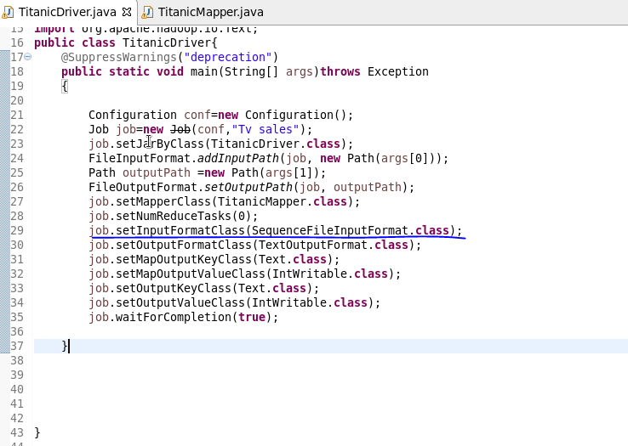

**Mapper Class:**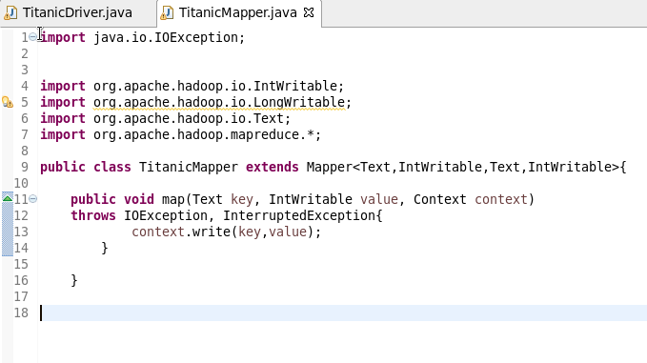

**Output:** 

